**Domain classes** ka matlab hota hai — **wo classes jo database ke table ko represent karti hain**.

**DbContext Class** – bridege between domain models and the database

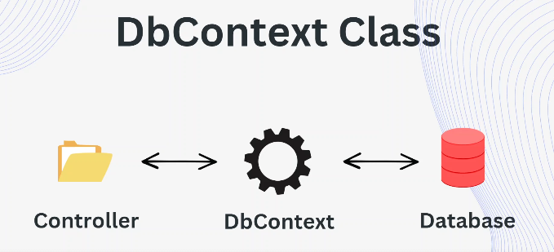

**✅ REST API – Short & Simple Definition:**

**REST API** ek aisa system hota hai jo **web ke through data exchange** karta hai, jaise **client aur server ke beech mein**.

**✅ HTTP Verbs – Short and Simple:**

**HTTP Verbs** (ya Methods) batate hain **client server se kya chahta hai** — data lena, bhejna, update ya delete karna.

✅ **ASP.NET Core Web API – Short & Simple Definition (Hinglish)**

**ASP.NET Core Web API** ek framework hai jisse aap **REST APIs** bana sakte ho **C# aur .NET Core** ka use karke — jisse client apps (React, Angular, mobile) data send/receive kar sakein.

✅ **REST API ke 6 Principles – Simple Explanation (Hinglish)**

**REST (Representational State Transfer)** ke kuch rules hote hain jinke basis pe ek **RESTful API** banti hai.

**🔹 1. Client-Server Architecture**

**Client** (browser/app) aur **server** (API/data logic) alag-alag hote hain.  
📱 App sirf request karega, 🖥 Server data handle karega.

**🔹 2. Stateless**

Har request server ko **fresh** aur **complete** honi chahiye.  
🔁 Server ko previous request ya session ka koi yaad nahi.

**🔹 3. Cacheable**

Response ko **cache** kiya ja sakta hai for better performance.  
🗂 Jaise product list baar-baar server se na aaye.

**🔹 4. Uniform Interface**

Ek consistent tariqa hona chahiye API ke use ka.  
📌 URL + HTTP Verb (GET/POST) ka ek proper format follow ho.

Example:

GET /api/students

POST /api/students

**🔹 5. Layered System**

Server multiple layers me ho sakta hai (auth, data, logging)  
🔐 Client ko pata nahi hota ki data kis layer se aa raha hai.

**🔹 6. Code on Demand (Optional)**

Server client ko kuch **code** (like JS) bhej sakta hai to execute.  
⚠️ Rarely used.

**Null or Empty String**

**🔹 1. null:**

* Variable **kisi bhi value ko point nahi kar raha**.
* Memory me kuch assign hi nahi hua.

string name = null;

**🔹 2. empty ("" ya string.Empty):**

* Ek **valid string hai**, par usme **koi character nahi hai**.

string name = "";

**🔸 Check karne ke examples:**

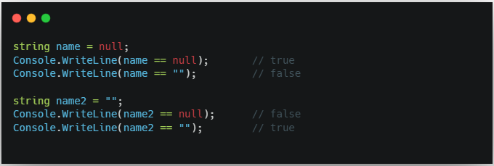

**🔸 Summary:**

| **Type** | **Value** | **Meaning** |
| --- | --- | --- |
| **null** | **no value** | **kuch assign hi nahi hua** |
| **""** | **empty string** | **value hai, but khaali hai** |

**✅ Always check both in validation:**

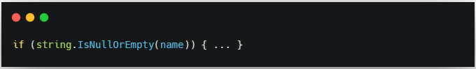

**Null Int**

**🔹 1. int (Non-nullable)**

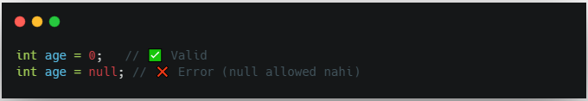

Normal int me null assign nahi kar sakte.

Sirf 0, 1, -5 jaise numbers assign kar sakte ho.

0 ka matlab hai zero value, not missing

**🔹 2. int? (Nullable int)**

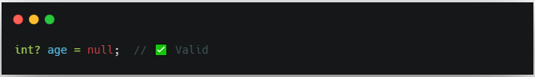

int? ka matlab: value ho bhi sakti hai ya nahi bhi.

Isse aap null assign kar sakte ho.

**🔸 Check karne ka example:**

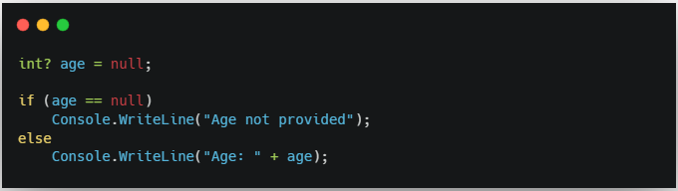

| **Type** | **null allowed?** | **0 ka matlab** | **null ka matlab** |
| --- | --- | --- | --- |
| **int** | **❌ No** | **Zero value** | **Not allowed** |
| **int?** | **✅ Yes** | **Zero value** | **Value not provided / missing** |